**CLONING THE BLOOM SINGLE-PAGE WEBSITE**

**(STATIC VERSION)**

**Project Title:**

Cloning the Bloom Single-Page Website (Static Version)

**Role**

Front-End Development Intern

Technology Stack

* HTML5 for semantic and accessible structure
* **CSS3** for styling, layout, and visual presentation

**Project Context:**

You have recently joined a front-end development team. Your first task as an intern is to replicate a static single-page website layout. Your mentor has provided a screenshot of a modified Bloom website, and your objective is to accurately recreate the design using only HTML and CSS.

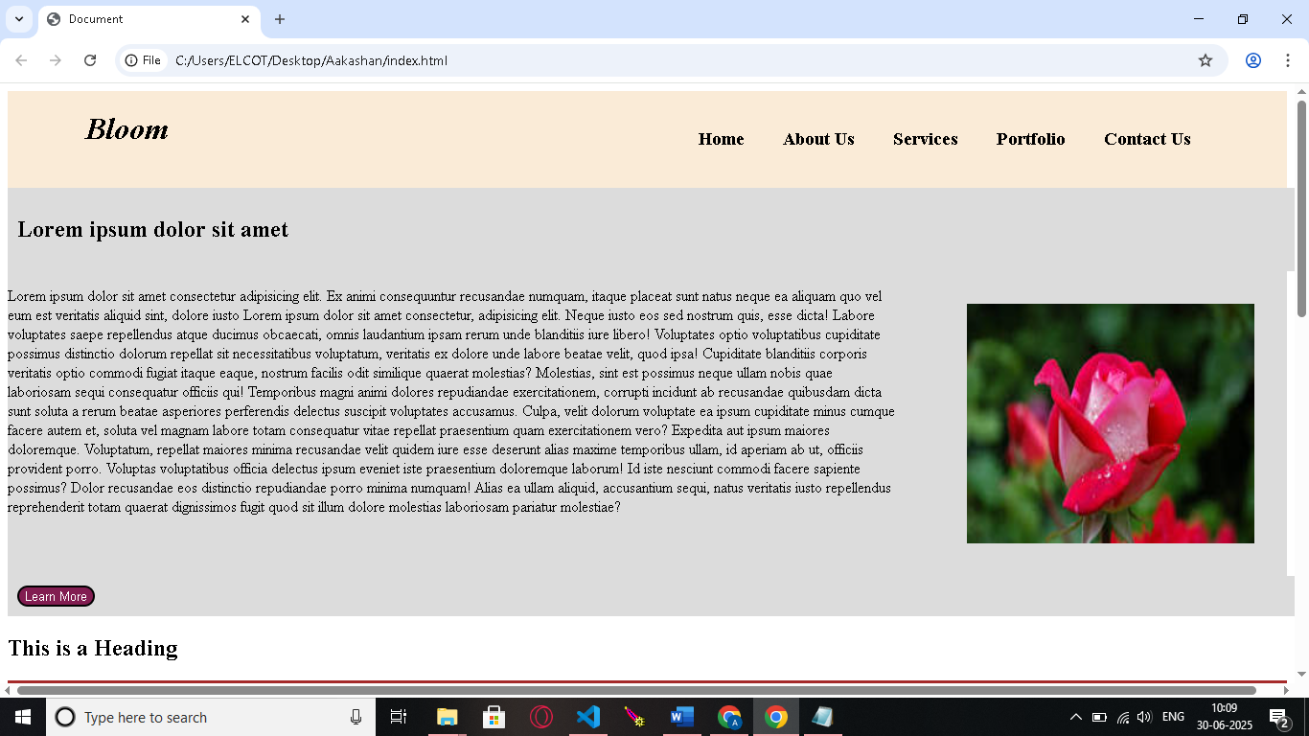

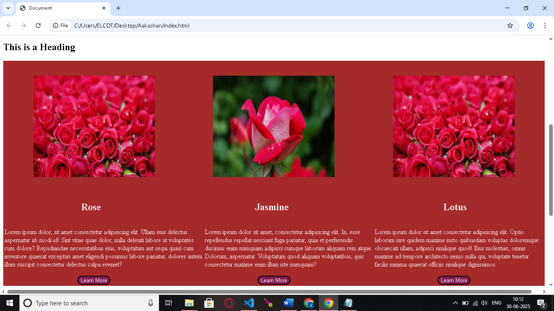

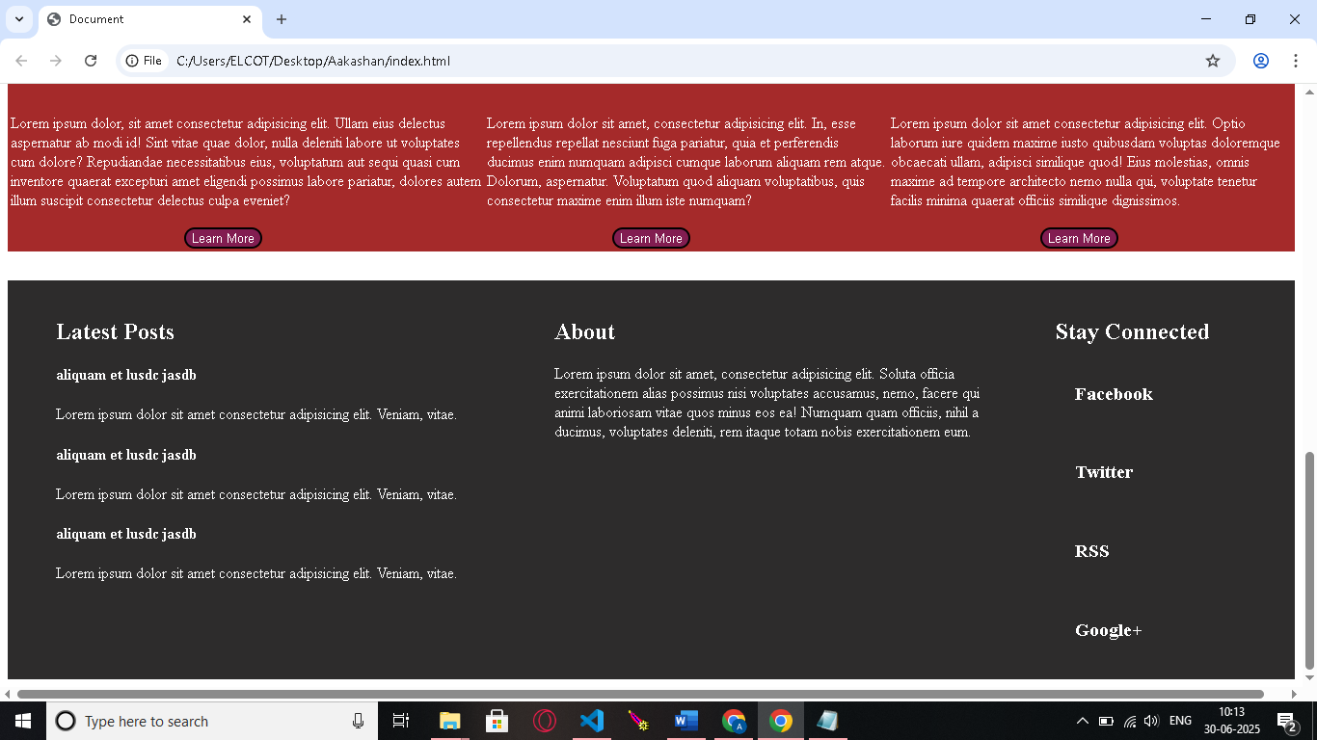

**OBJECTIVE:**

To recreate the visual layout and design of the given Bloom website screenshot using semantic HTML elements and clean, maintainable CSS styling. The cloned version should closely match the reference in structure, spacing, and overall appearance.

**Task Requirements:**

* Use semantic HTML5 elements for clear and accessible structure (<header>, <nav>, <section>, <footer>, etc.)
* Apply only CSS for:
  + Layout (e.g., Flexbox, Grid)
  + Typography (fonts, colors, spacing)
  + Visuals (borders, background colors, shadows)
  + Buttons and other UI elements

**Recreate all visible sections**:

* + **Navigation bar** – with logo/text and menu links
  + **Hero section** – featuring main headline, text, and an image
  + **Services/Portfolio section** – displayed using styled cards
  + **Footer section** – structured into 3 columns:
    - Latest Posts
    - About
    - Social Media links

**Ensure accurate:**

* + Alignment and spacing
  + Font sizes and styles
  + Color scheme (based on screenshot or palette)

**Constraints:**

* **No JavaScript** (no interactivity required)
* **No CSS frameworks** (e.g., Bootstrap, Tailwind)
* Only use **vanilla HTML and CSS**
* Placeholder images or boxes are acceptable for visuals

**Deliverables:**

1. **index.html** – The full semantic HTML structure of the Bloom clone
2. **style.css** – CSS file containing all layout and visual styles
3. **Asset folder** (optional) – For placeholder images or icons if needed
4. **Screenshot of the cloned version** – A full-page image of your recreated version
5. **Screenshot of the original reference** – The given Bloom layout screenshot
6. **README.md file** containing:
   * A brief overview of the Bloom website’s layout and design style
   * Simplifications or assumptions made (e.g., using placeholder images, approximate font sizes)
   * Challenges encountered and how they were resolved (e.g., layout responsiveness, card alignment)

**Bonus Challenge (Optional):**

* **Responsive Design**: Use **CSS media queries** to ensure layout adapts to mobile and tablet screens
* **Hover Effects**: Add visual hover effects to navigation links, buttons, or cards for a more dynamic feel